PERSONAL INFORMATION
Last Name: | Aguilar Bazán
Middle Name: | Diane
First Name: | Edissa
Gender: | Female
Date of Birth: | March/21/1995
Place of Birth: | Trujillo, Peru
Address: | Mz 4 Lte 1 – 4 Sector Wichanzao – La Esperanza
E-mail: | diane.aguilar416@gmail.com
Cellphone: | 979 679 656
Skype: | Diane.Aguilera

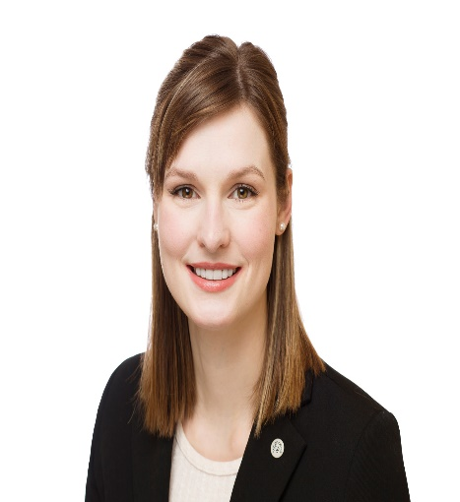

AVAILABLE DATES TO WORK IN USA
Work in USA from: | December/15/2017
Work in USA to: | March/29/2017

LANGUAGES:
Spanish | Native
English | Intermediate

JOB PREFERENCE
1. F&B Host
2. Housekeeping
3. Spa Attendant
1
EDUCATION
Field of Study: | Tourism and Hospitality Management
Field of Study: | Católica de Trujillo Benedicto XVI University
Location: | Trujillo - Peru
Start date: | March/2012
Graduation date: | March/2017
2
WORK EXPERIENCE
Company Name: | Travel Agency “Tourism Carolina Travel S.A.C.”
Position: | Practitioner of Counter
Location: | Trujillo - Peru
Duration: | From April/2015 to July/2015
Responsibilities: | - Registration of users in the system of sales.  - Perform the reservation of the services required and fare quote.  - Sale of travel tickets air and land.  - Elaboration of tourist packages.
Company Name: | Hotel “Pullman”
Position: | Practitioner of Receptionist and Housekeeping
Location: | Trujillo - Peru
Duration: | From September/2015 to November/2015
Responsibilities: | - Register to the guests.  - Effectively manage reservations.  - Register, check and charge the services consumed by the guests.  - Prepare the cleaning materials.  - Perform the cleaning and coverage of the rooms.  - Report objects lost & found, damaged or missing from the rooms.
Company Name: | Tourist Restaurant “The Hat”
Position: | Practitioner of Stewardess
Location: | Trujillo - Peru
Duration: | From April/2016 to July/2016
Responsibilities: | - Arrangement and preparation of the lounge and service stations, handling of utensils, crockery, cutlery, glassware and equipment considering the type and style of service to be used.  - Perform the procedures for reception, pre-sales and order taking diners.  - Cleaning the main salon and the different areas of the restaurant.

COMPUTER SKILLS
Excel
Word
Power Point

PERSONAL SKILLS
- Capable of work under pressure. | - Talkative
- Leadership | - Charismatic
- Empathic | - Teamwork

ACTIVITIES & INTERESTS
I study Tourism and Hospitality Management at the university because I think it is one of the futures of career, because each day the tourism grows and there are no qualified personnel for the adequate attention of tourists. In addition to this, I think that this career allows you to recognize other cultures and that the other knows yours and this is a fun way to learn.

About my interests, I like to go to the movies with my friends, listen music (Rock, Pop and Kpop), Watch dramas and series. Also I like to read every kind of books, especially books about countries. I like dance and sing.

3
1

